**Lab#12(a) Implement Delete Operation in Laravel with GUI.**

|  |  |  |
| --- | --- | --- |
| **COMMAND USED** | **ATTRIBUTES USED** | **DESCRIPTION** |
| Artisan | make:controller, make:model, make:migration, serve | In Laravel, Artisan is a command-line tool that provides a wide range of commands for various tasks related to the development and management of Laravel applications. Artisan simplifies common development tasks by automating them through command-line commands. |

**Final Outcome:**

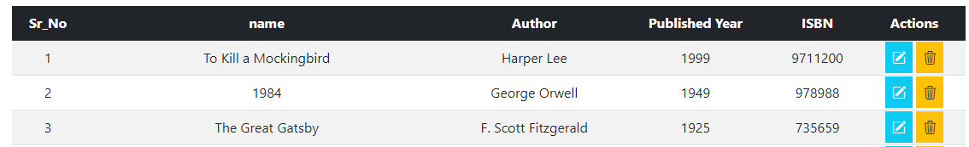

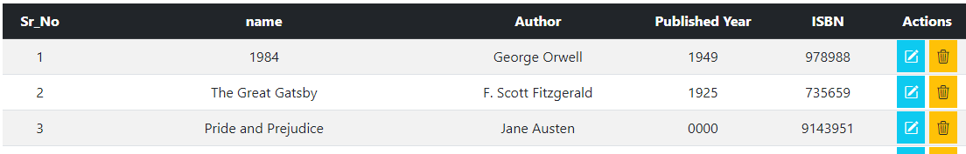

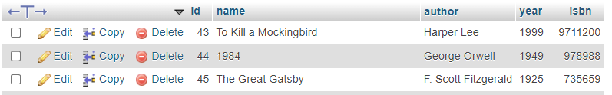

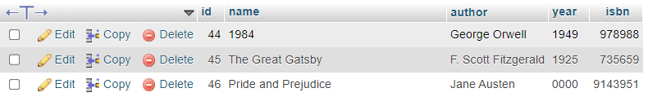

**Code Snippet:**

**DBCONTROLLER.php**

<?php

namespace App\Http\Controllers;

use Illuminate\Support\Facades\DB;

use App\Http\Controllers\Controller;

use Illuminate\Http\Request;

class dbcontroller extends Controller

{

public function dbselect(Request $req)

{

$search=$req['data']??"";

if($search!="")

{

$search=$search.'%';

$r=DB::select('select * from bookinfo where name LIKE ?',[$search]);

}

else{

$r=DB::select('select * from bookinfo');

}

$data=compact('r','req');

return view('view')->with($data);

}

public function delete($id)

{

$r=DB::delete('delete from bookinfo where id=?',[$id]);

return redirect('/');

}

public function edit($id,Request $req)

{

$row_affected=DB::update('update bookinfo set name=?,author=?,year=?,isbn=? where id=?',[$req['name'],$req['author'],$req['year'],$req['isbn'],$id]);

return redirect('/');

}

public function fetchdata($id)

{

$r=DB::select('select * from bookinfo where id=?',[$id]);

$url=url('/edit').'/'.$id;

$edit=true;

$data=compact('r','edit','url');

return view('add')->with($data);

}

}

**web.php**

<?php

use Illuminate\Support\Facades\Route;

use App\Http\Controllers\dbcontroller;

Route::get('/', [dbcontroller::class,'dbselect']);

Route::get('/add', function()

{

$url=url('/add');

$data=compact('url');

return view('add')->with($data);

}

);

Route::get('/delete/{id}',[dbcontroller::class,'delete'])->name('book.delete');

Route::get('/edit/{id}',[dbcontroller::class,'fetchdata']);

Route::post('/edit/{id}',[dbcontroller::class,'edit'])->name('book.edit');

Route::post('/add',[dbcontroller::class,'add']);

­

**Lab#12(b) Search Operation in Laravel with GUI.**

**Final outcome:**

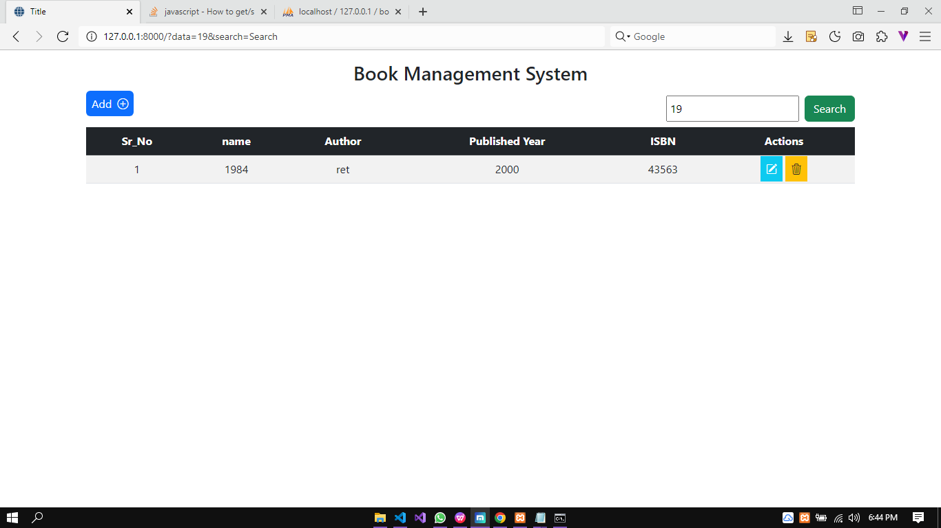**Searching for a book which starts from ‘19’**

**Code snippet:**

**Web.php**

<?php

use Illuminate\Support\Facades\Route;

use App\Http\Controllers\dbcontroller;

Route::get('/', [dbcontroller::class,'dbselect']);

Route::get('/add', function()

{

$url=url('/add');

$data=compact('url');

return view('add')->with($data);

}

);

Route::get('/delete/{id}',[dbcontroller::class,'delete'])->name('book.delete');

Route::get('/edit/{id}',[dbcontroller::class,'fetchdata']);

Route::post('/edit/{id}',[dbcontroller::class,'edit'])->name('book.edit');

Route::post('/add',[dbcontroller::class,'add']);

**View.blade.php:**

public function dbselect(Request $req)

{

$search=$req['data']??"";

if($search!="")

{

$search=$search.'%';

$r=DB::select('select * from bookinfo where name LIKE ?',[$search]);

}

else{

$r=DB::select('select * from bookinfo');

}

$data=compact('r','req');

return view('view')->with($data);

}